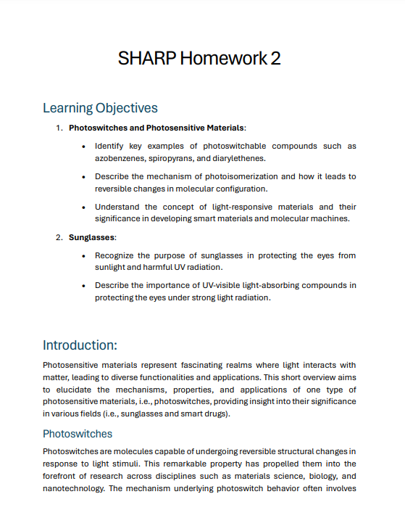

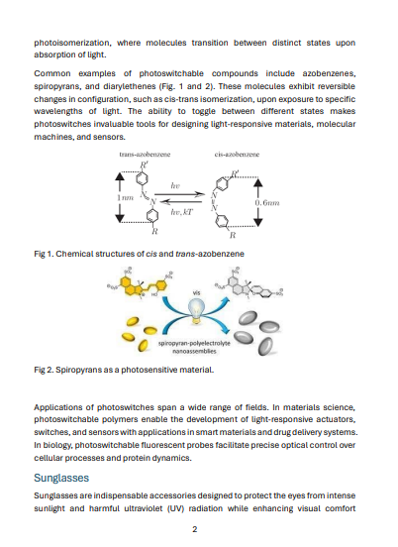

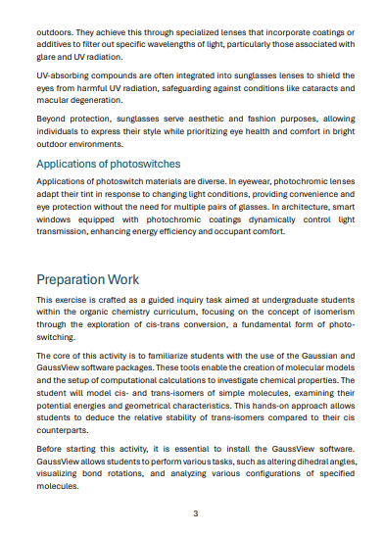

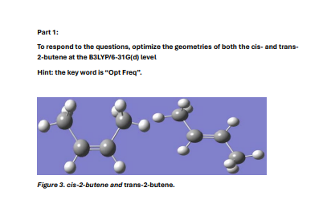

Question 1.

Measure C=C bond lengths in the cis- and trans-2-butene and explain why they are slightly different.

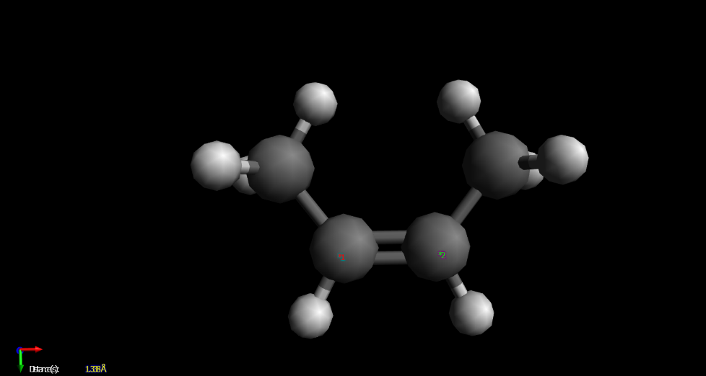

**Cis-2-butene: 1.338Å**

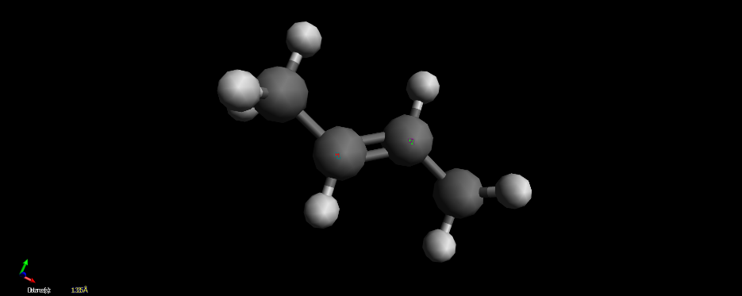

**Trans-2-butene: 1.335Å**

**Trans-2-butene has a shorter bond length than Cis-2-butene potentially because of the Trans-2-butene has staggered alkyl groups, rather than both being on the same side as in the case of Cis-2-butene. This minimizes the steric hindrance and repulsion between the alkyl groups, causing the C=C bond to be closer together, resulting in Trans-2-butene having a shorter bond length than Cis-2-butene.**

Question 2.

Measure and record the dihedral angles of C-C=C-C in the cis- and trans-2-butene.

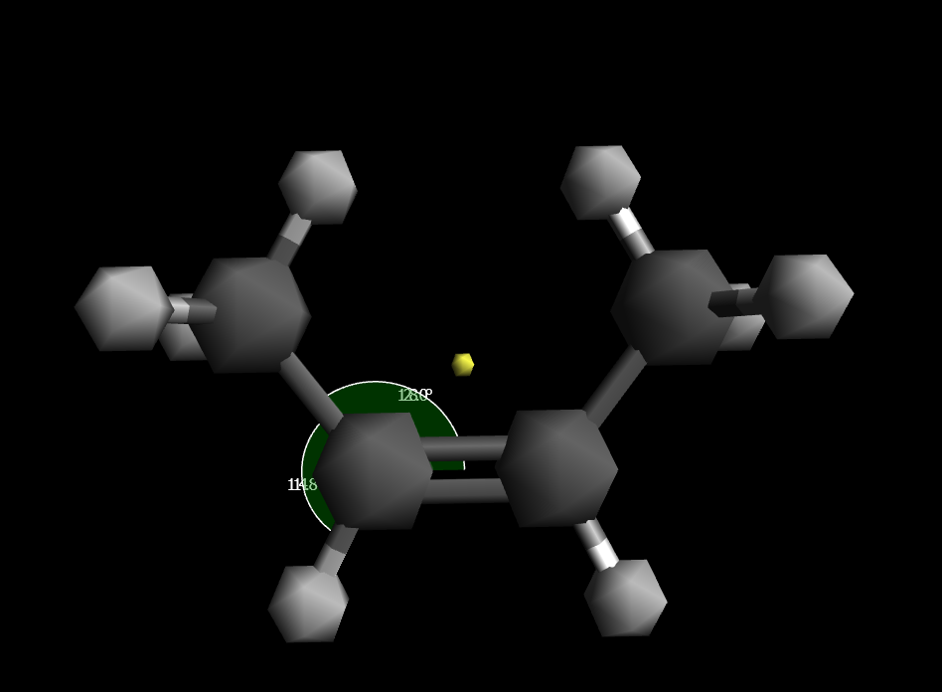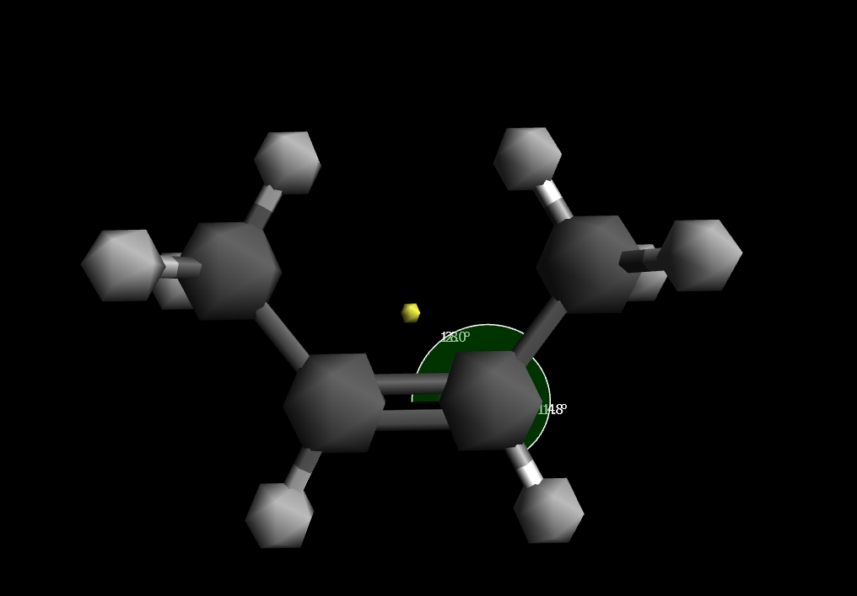

**Cis-2-butene: 114.8° and 128.0°**

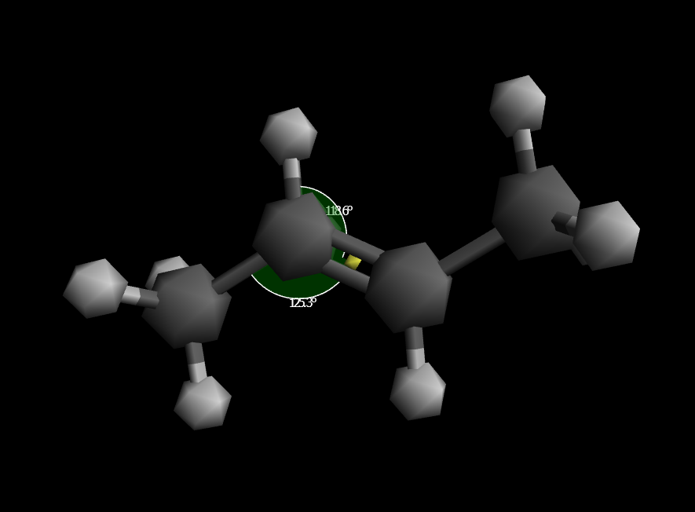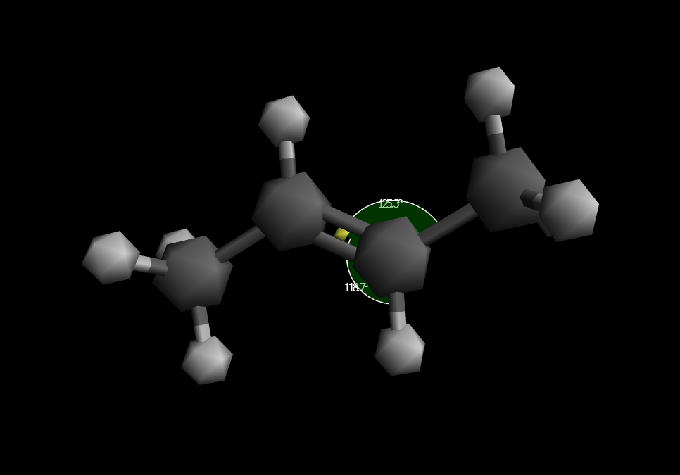**Trans-2-butene: 118.6° and 125.3°**

Question 3.

According to the obtained energies, which isomer is more stable? The cis or the trans? Can you guess why one is more stable than the other?

**The Trans-2-butene isomer is more stable than the Cis-2-butene, with the Cis-2-butene isomer being about 5 kJ/mol less stable than the Trans-2-butene isomer.**

**This is because the Trans-2-butene isomer has a shorter bond length (1.335Å) than the Cis-2-butene isomer (1.338Å), which results in it having a stronger bond strength, between the C=C bond, hence it is more stable than the Cis-2-butene isomer.**

Reference: Libretexts. (2023, October 8). 7.7: Stability of alkenes. Chemistry LibreTexts. <https://chem.libretexts.org/Bookshelves/Organic_Chemistry/Organic_Chemistry_(Morsch_et_al.)/07%3A_Alkenes-_Structure_and_Reactivity/7.07%3A_Stability_of_Alkenes>

Question 4.

**Design Challenge:** Imagine a photoswitch capable of reversible transitions between two states: a stable state (A) and a metastable state (B). Detail the optimal optical properties, specifically the absorption intensities at various wavelengths, required to render this photoswitch perfect for use as a dopant in sunglasses. Additionally, propose a working mechanism that would enable this photoswitch to excel in its role, enhancing the adaptability and effectiveness of sunglasses in varying light conditions (i.e., outdoors vs. indoors).

**The Optimal Optical Properties:**

* **The photoswitch molecule must be able to change its configuration state from the stable state (A) to metastable state (B) upon absorbing energy at specific wavelengths (e.g. the wavelength of UV light (300nm-400nm) emitted by the Sun), reducing the amount of said specific (UV light) wavelengths from reaching the eye.**
* **Both of its states of the photoswitch molecule must not absorb visible light wavelengths to ensure normal vision.**
* **The photoswitch molecule must be able to reverse its state from metastable state (B) to stable state (A) when said specific wavelengths (UV light wavelength of 300nm-400nm emitted by the Sun) are no longer present.**

**Working Mechanism:**

1. **Said photoswitch molecule could be a molecule with a central C=C bond, with cis-trans isomers.**
2. **Upon absorbing specific wavelength energies such as UV light of 300nm to 400nm emitted by the Sun outdoors, it will transit from its stable state (A), usually the more stable trans-isomer, to the metastable state (B), usually the less stable cis-isomer. This reduces the amount of UV light reaching the eye.**
3. **Upon returning indoors, there is less UV light supplied, and the photoswitch molecule returns from the metastable state (B) to its stable state (A).**